Relative Pronouns

🔹 What Are Relative Pronouns?
# Source: AI Source: Provided by: [Data Path: Persons Table -> ID Column: 1, Name_En Column: Motasem Essam] -> From: [Chatgpt (GPT-4-turbo)] on [7/27/2025]
Relative pronouns are words that connect a clause or phrase to a noun or pronoun.
They introduce relative clauses, which give more information about a noun.

✅ Common Relative Pronouns
# Source: AI Source: Provided by: [Data Path: Persons Table -> ID Column: 1, Name_En Column: Motasem Essam] -> From: [Chatgpt (GPT-4-turbo)] on [7/27/2025]
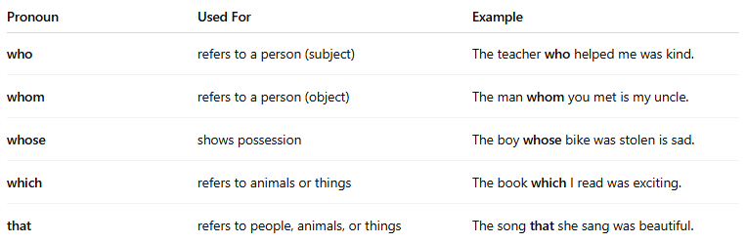
Pronoun | Used For | Example
who | refers to a person (subject) | The teacher who helped me was kind.
whom | refers to a person (object) | The man whom you met is my uncle.
whose | shows possession | The boy whose bike was stolen is sad.
which | refers to animals or things | The book which I read was exciting.
that | refers to people, animals, or things | The song that she sang was beautiful.

📚 Examples in Sentences
# Source: AI Source: Provided by: [Data Path: Persons Table -> ID Column: 1, Name_En Column: Motasem Essam] -> From: [Chatgpt (GPT-4-turbo)] on [7/27/2025]
- She’s the girl who won the prize.
- This is the actor whom we interviewed.
- I met a man whose dog can dance!
- Here’s the movie which made me cry.
- The cake that you baked is delicious.

🧠 What Do They Do?
# Source: AI Source: Provided by: [Data Path: Persons Table -> ID Column: 1, Name_En Column: Motasem Essam] -> From: [Chatgpt (GPT-4-turbo)] on [7/27/2025]
Relative pronouns:
- Replace a noun (like a pronoun does),
- Join two ideas into one sentence.
🔸 Example:
- Two sentences:
This is the man. He saved the child.
- Combined with a relative pronoun:
This is the man who saved the child.

⚠️ Note:
# Source: AI Source: Provided by: [Data Path: Persons Table -> ID Column: 1, Name_En Column: Motasem Essam] -> From: [Chatgpt (GPT-4-turbo)] on [7/27/2025]
- "That" is often used in restrictive clauses (essential info).
- "Which" is used in non-restrictive clauses (extra info, usually with commas).

